DOCUMENTATION

**INTRODUCTION**

We developed a real time tracking solution to be used by small and medium businesses (SMEs), using an embedded google map for ease in tracking their goods to get a definite answer to where exactly their goods are and to reduce the burden on (SMEs) who have to deal with angry and agitated customers hounding them on their precise location of their goods.

**Approach to the project**

* Collection and compilation of data: data was collected through Quantitative data collection which involved administering online surveys to a sample of the population. The survey instruments include questionnaires which had close ended questions as well as open ended questions for qualitative feedback.
* Jupyter Notebook was used for analysis

**Data preparation**

* The data was collected using a questionnaire and was being read into a google sheet.
* Importing necessary libraries on notebook environment
* Read in the dataset
* Get full information of the dataset

**Data cleaning**

* Dropping unnecessary columns : we dropped Time, Feedback and Feature request columns as analysis cannot be carried out on them
* Handling missing values : we had some null values in the dataset and used the Median (middle value) to fill in the missing value.
* Standardization of the dataset : real time update importance had both strings and integers so it had to be converted into integers for each in analysis.
* Handling invalid values : Nationality were not properly grouped and contained some invalid values

**Exploratory data analysis (EDA)**

Questions we generated

* Demography (Age, Gender, Nationality)
* Demography vs Delivery Service Usage
* Demography vs Real Time Usage
* Correlation between delivery service vs real time tracking feature
* Ease of tracking items
* Tracking ease vs satisfaction
* Frequency of delivery usage
* On time delivery vs Real Time Tracking Usage
* Challenges
* Satisfaction vs Challenges
* Real time update Importance
* Map integration Willingness
* Map integration Willingness across Demography

**Insights**

Demography

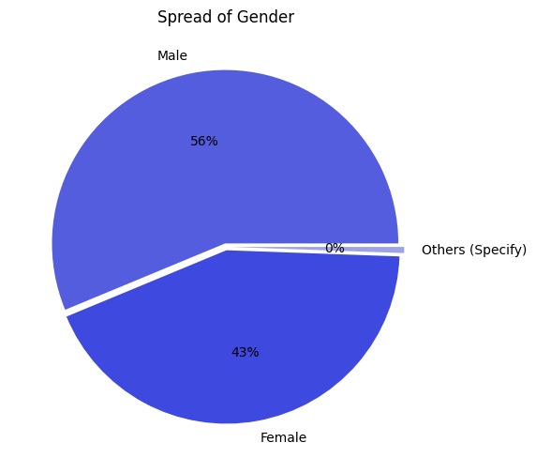 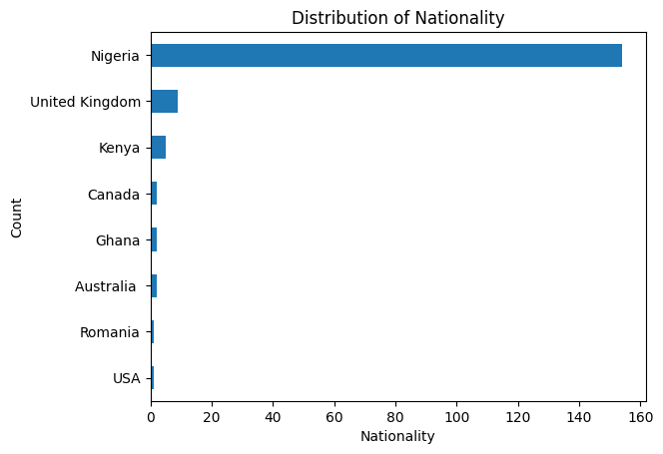 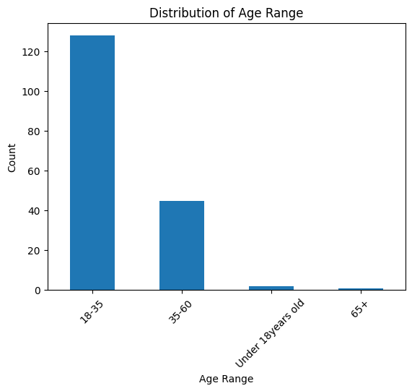

* Females are our highest respondent in our dataset having 56%.
* Most of our respondents are from Nigeria, because of the use of convenience random sampling due to time constraints.
* There is a high response from 18-35 years, this implies our target audience are within the Gen Z and Millennial generation.

Tracking Ease vs Satisfaction

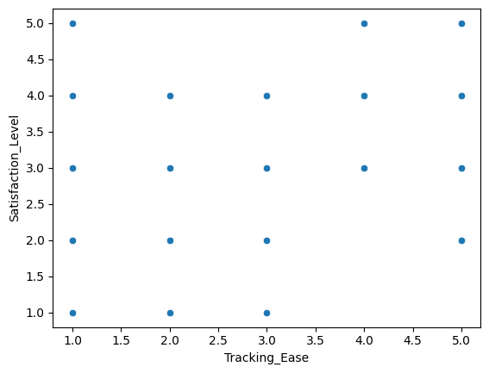

A correlation coefficient of **0.515** indicates a moderately strong positive correlation between "**Tracking_Ease**" and "**Satisfaction_Level**". This suggests that customers who find it easier to track their shipments tend to have higher satisfaction levels, which aligns with expectations as ease of tracking likely contributes positively to overall customer experience and satisfaction.

However, it's important to note that **correlation does not imply causation**, so while these variables may be correlated, there could be other factors influencing satisfaction levels.

Real time tracking importance

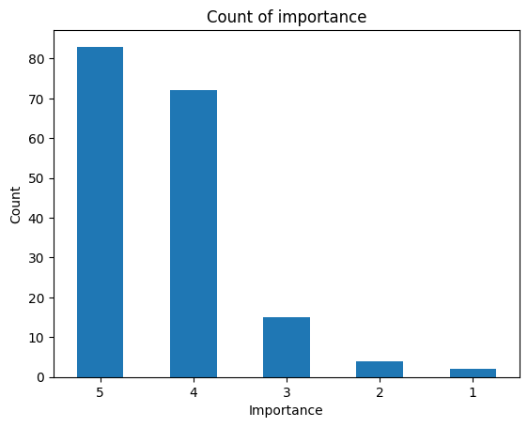

Insights

* Majority of respondents expressed a strong preference for receiving real-time update importance about their products.
* This indicates there is a market demand for this feature

Map integration willingness

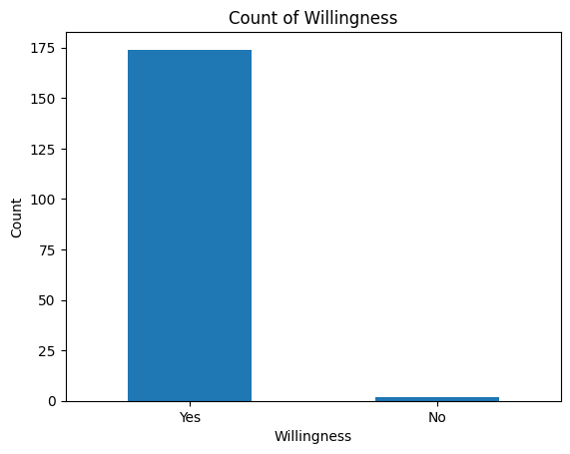

Insights

* About 99% of our respondents expressed a strong willingness to use the proposed feature, indicating a significant demand within our target market also.
* The overwhelming positive response from our respondents shows a promising opportunity for successful implementation and adoption of the feature

**CONCLUSION**

* The high performance suggests a strong support for the hypothesis that respondents would be willing to use our product upon its launch. It indicates favorable market potential and consumer interest in the proposed features.